PROJECT DOCUMENTATION

Personalized Networking Assistant
An AI-Powered Web Application for Smart Networking
ABSTRACT
The Personalized Networking Assistant is an AI-powered web application that helps users generate smart, tailored conversation starters for professional or social networking events. It uses DistilBERT for extracting themes from event descriptions and GPT-2 for generating context-aware conversation prompts. The platform also offers fact-checking using the Wikipedia API and allows users to log their conversation history and provide feedback on suggestions to improve personalization.
Built using FastAPI and Streamlit, the application ensures a responsive, interactive, and modular architecture. All components are unit-tested using pytest, with clearly defined backend services, routes, and a dynamic frontend.

Introduction
This project helps users prepare for networking events by generating context-aware conversation starters using AI.

Problem Statement
People often find it difficult to start meaningful conversations at networking events. The Personalized Networking Assistant addresses this by analyzing event context and generating relevant, personalized conversation openers.

Objectives
- Detect event themes
- Generate conversation starters
- Verify facts using Wikipedia
- Store history and feedback

Technologies Used
Python, FastAPI, Streamlit, DistilBERT, GPT-2, Wikipedia API, JSON, Git, GitHub.

Skills Required
- FastAPI
- Streamlit
- API Integration & Data Modeling
- Python (Programming Language)
- Natural Language Processing
- Generative Artificial Intelligence
- Model Optimization
- Transformers
- Large Language Models (LLMs)
- Ethical AI

Modules
- Event Analyzer
- Topic Generator
- Fact Checker
- History Logger
- Feedback Logger
- Frontend
- Backend

Workflow
User enters an event description → Themes detected → Conversation starters generated → Fact checking → History and feedback saved.

Usage Scenarios

Scenario 1: Generating Smart Starters
A user enters an event description such as "AI for Sustainable Cities" and specifies interests like "climate change" and "urban planning." The assistant extracts themes (e.g., AI, sustainability) and generates 2–3 conversation starters aligned with the user's goals.

Scenario 2: Quick Fact Verification
A user preparing to attend a conference searches for a quick fact check on "blockchain in healthcare." The app provides a summarized, reliable reference using the Wikipedia API.

Scenario 3: Reviewing Past Strategies
A user accesses the "History" feature to review previously generated conversations, and which ones were marked useful (thumbs up). This encourages continuous improvement in networking skills.

System Requirements

Hardware Requirements
- Processor: Intel i3/i5 or higher
- RAM: Minimum 4GB (8GB Recommended)
- Storage: 10GB Free Disk Space
- Internet Connection Required

Software Requirements
- Operating System: Windows / Linux / macOS
- Python 3.10+
- FastAPI
- Database (SQL / PostgreSQL / SQLite)
- Google Gemini API Key
- Git & GitHub
- Visual Studio Code / PyCharm

Project Flow
- Epic 1: Model Selection and Architecture
- Epic 2: Core Functionalities Development
- Epic 3: Main Application Logic
- Epic 4: Frontend UI Using Streamlit
- Epic 5: Testing and Local Deployment

Application Output
The screenshots below show the deployed Streamlit application running locally at localhost:8501, demonstrating the theme detection, conversation starter generation, and Wikipedia-based fact-checking features.
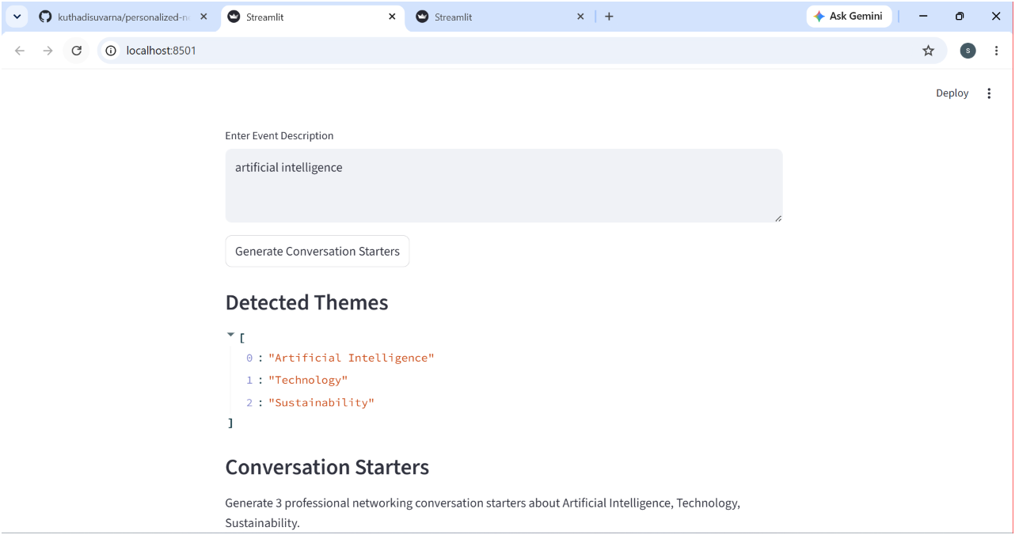
Figure 1: Theme detection and conversation starter generation for the topic "artificial intelligence"
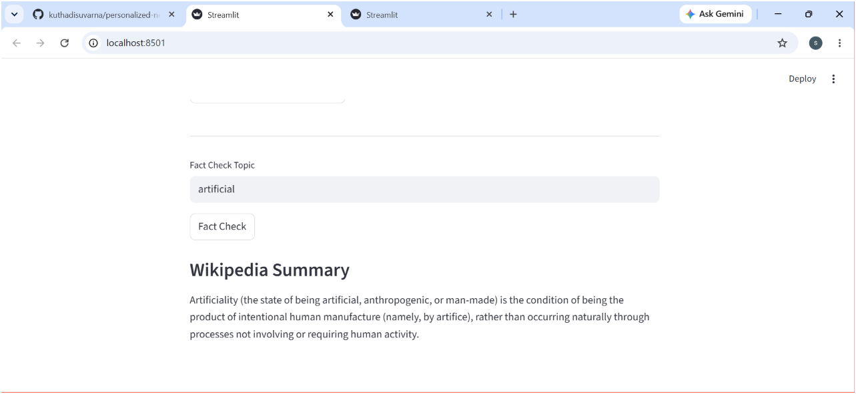
Figure 2: Fact-checking feature showing a Wikipedia summary for the queried topic

Testing
The following components were verified: Event Analyzer, Conversation Generator, Fact Checker, History Logger, Feedback Logger, Frontend, and Backend. All modules were unit-tested using pytest.

Results
The application successfully generated networking conversation starters and stored user interactions. As demonstrated in the screenshots above, the app correctly detected relevant themes and returned an accurate, real-time Wikipedia summary for fact verification.

Project Links
GitHub Repository:https://github.com/kuthadisuvarna/personalized-networking-assistant
DEMO VIDEO (Google Drive):

https://drive.google.com/file/d/1ucwV7Ong6PmNfCXQ9J9XpETTBpWNz8nK/view
- User authentication
- Cloud deployment
- Database integration
- Multilingual support

Conclusion
The project demonstrates practical use of AI for professional networking assistance, combining theme detection, generative language models, and real-time fact verification into a single, modular, and testable application.

References
FastAPI Documentation
Streamlit Documentation
Hugging Face
Wikipedia
GitHub Repository

